Specifications-Prisoner Transport Van with Three-Compartment Insert:
- Model Year: 2022 or later; brand new.

- Model: Extended Cargo Van, following specifications herein.

- GVWR: 9500 lbs. minimum

- Height: Total “street-to-top” height shall not exceed 84.6 inches on fully inflated tires, without passengers or cargo.

- Fuel Requirement: Fuel rating of E10 or higher.

- Engine:
Displacement: 5.4 L gasoline V8 minimum.

Fuel Induction: Fuel injection.

- Power Train
Components:

Transmission: Heavy duty electronic 4-6 speed electronic automatic transmission with overdrive.

Differential: Rear Wheel Drive.

- Charging System:

Battery: Appropriate for anticipated load.

Alternator: Appropriate for anticipated load.

- Suspension: Heavy-duty suspension calculated, designed in accordance with vehicle GVW, including the prisoner insert kit. Front and rear sway bars if available.

Front: Heavy Duty application shock absorbers.

Rear: Heavy Duty application hydraulic shock absorbers.

- Cooling System: Appropriate for anticipated load.

- Braking System: Disc, with anti-lock brake system (ABS).

- Body: Double wall construction.

- Steering: Power-steering, HD application.

- Air Conditioning: DUAL A/C, OEM Front & rear units.

- Doors: Side and rear swing-out doors, to be opened only from the outside.

- Locks (Doors): Vehicle shall be equipped with standard electric power door locks to be controlled by driver only, except that the front-passenger door-lock can also be operative by front passenger.

- Glass: Factory legal tinted glass within legal limits on front windshield, driver, and passenger door. Windows in rear and side swingout doors to have fixed privacy glass. No other windows.
Specified tinting may be applied after receipt of the vehicle, and prior to final delivery to destination.

Driver’s-side window, and front-passenger window, shall be powered, and operated by driver. Front passenger window to be also operated by front passenger.

- Tires & Rims: Standard HD OEM tires and rims designed for the vehicle weight and application.

- Key Equipment: Single key system, with three (3) sets of keys, and key fobs furnished for each unit. This is to include keys for any standard compartments.

- Floor covering: Full black vinyl.

- Mirrors: Dual electrical (power) mirrors.

- Radio: Factory AM/FM stereo

- Vehicle Color: Vehicle shall be painted factory white.

- Emission Standards: Manufacturers standard equipment and all devices necessary to comply with the Federal Motor Vehicle Safety Standards shall be included. Vehicle must comply with all Federal Emission Standards on crankcase, exhaust, and applicable Hawaii State Laws.

- Other: Three (3) warning triangles.
Operator’s Manual. Electronic format is acceptable.

Service and repair manuals (2 sets). Electronic format is acceptable.

All factory technical bulletins pertaining to service/repair revisions and identification of new replacement parts from vehicle manufacturer shall be provided by the successful Bidder to the Department of Public Safety/Halawa Correctional Facility

- Prisoner Transport Van Emergency Warning Lighting:

This van will be equipped with mid-level LED (amber/white) emergency lighting in front and rear. There will be no light bar on the roof. Specifications as follows:

NOTE: WHELEN EMERGENCY LIGHT PART NUMBERS ARE USED FOR SPECIFICATION REFERENCE ONLY. HAVIS CONSOLE/ITEMS PART NUMBERS ARE USED FOR SPECIFICTION REFERENCE ONLY.

SUBSTITUTIONS: INTERESTED BIDDERS SHALL REQUEST AND RECEIVE WRITTEN APPROVAL FROM THE AUTHORIZED REPRESENTATIVE FOR SUBSTITUTIONS THAT THE CONTRACTOR CONSIDERS “EQUAL TO” THE SPECIFIED ITEMS LISTED PRIOR TO SUBMITTAL OF BID.

GENERAL DESCRIPTION: The contractor shall furnish and install the following specified components for a fully functional system. All wiring shall be fuse circuit protected, of appropriate wire gauge and rating, with fuses labeled / identified as to component line function. Factory pre-wired packages or harnesses may be used, but will be continuous between the associated component, switch function, and follow the color code from end component back to the control unit with the minimum number of splices and be of the appropriate gauge wire.

The use of thermal circuit breakers is not acceptable. All wiring funs where exposed shall be wire loom protected. All wires running through metal panels shall use grommets. The installer shall be an authorized dealer for the Emergency lighting product, and the contractor shall be responsible for all warranty service on the island of Oahu during the manufacturer’s warranty period of the specified components.

The successful Bidder’s representative and the Lead Installer for the Emergency Lighting System shall meet with the appropriate Authorized Representative for the transport van prior to the installation of any equipment to review build requirements.

Emergency Warning / Lighting System: The contractor shall furnish and install the Whelen Engineering, or equal, specified models or prior approved equivalent in the Prisoner Transport Van.

Front Grille: Install two each (2) Whelen model MJ7 or use 50RB02ZCR, with Whelen model M7 flange of appropriate color matching grille surface mount adapters on exterior horizontal bars of grille. Installer shall synchronize light heads in an alternating pattern.

Front Fenders: Install two each (2) Whelen model M4 (amber/white) Series Linear Super-LED light heads, with appropriate adaptor on forward side portion of the front fenders, one on each side.

Front Mid-Level Install two each (2) Whelen model AVNS2RB Avenger Series Linear
Lighting: Super-LED light heads, with appropriate headliner mounting brackets installed forward facing at top portion of windshield area.

Rear Doors: Install two each (2) Whelen model AVNS2RB Avenger Series Linear Super-LED light heads, with appropriate mounting brackets installed rear facing at lower portion of rear glass window area, rear facing.

Rear Taillights: Install two each (2) Whelen model VTX609R Super-LED light assemblies, one in each taillight.

Switching: Installer shall use optional O.E.M. in dash illuminated switches (if available), or installer provided optional illuminated switches in Havis, Inc. communication console. Functions shall be one (1) switch for front emergency warning lights, and one (1) switch for rear emergency warning lights.

Rear and Side Steps The contractor shall provide and install a slide or folding step at
and Warning Light prisoner exit door(s), with warning light and buzzer in the driver
and Buzzer: compartment to notify operator/driver that the rear and side steps are in the extended/deployment mode.

Rear Reverse Alarm Transport van shall have reverse warning alarm and reverse
and Proximity Sensor: proximity alarm installed to warn pedestrians that the van is reversing and to warn driver of distance to rear obstacles.

Metal Gun Locker: The contractor shall install and at time of installation, state provided metal handgun lock boxes at location between the front seats pursuant to officer in charge.

- Prisoner Transport Van: The contractor shall furnish and install the following:
This van shall be comprised of a manufactured unit/shell that is specifically designed for prisoner security/safety. It is the bidding contractor's responsibility to ensure that a manufactured prisoner transport kit, Havis Kwik Kit or equal, is available for their proposed make/model van bid. Specifications as follows:

•PT-VIDE0-4, prewire for a four (4) video camera system. (One camera for each compartment and one camera for rear of each vehicle)

NOTE: VIDEO FOR EACH COMPARTMENT IS TO ENSURE PRISONER SAFETY AND SECURITY. MAINTAIN CUSTODY AND CONTROL IN THE EVENT OF ASSAULT, ESCAPES, AND HEALTH ISSUES. CUSTODIES WILL BE MONITORED AND APPROPRIATE ACTION WILL BE TAKEN.
• The Contractor shall install a W' treated ply board between the floor and transport shell kit to insulate sound.
• PT Optional ductwork kit that attaches to the OEM Rear Heat/A/C blower system to allow A/C ventilation into each compartment and vent guards to prevent prisoners from inserting/hiding of contraband. (KK-F-VAK)
• PT Vent option for removal of air from prisoner compartments. Shall not exceed 4" in height if mounted on roof. Mount on Rear panel acceptable. (KK-PVENT) One per compartment.
• PT Option sound deadening and insulation kit. (KK-SDI)
• PT Option, Rear Flip down step with contractor provided buzzer warning alarm and red lens light that warns the driver that the step is folded down. (KK-ST-FLIP)
• LED rear lights to improve reverse and removal of prisoners lighting. Contractor shall install light switches at rear door and in driver's compartment.
• All seams shall be silicone sealed to prevent contaminants from entering seams and allow easy removal and washing out of contaminants.
PT-VIDE0-4 Camera monitor screen (4). Interior sealed/secured lighting and camera for each compartment in prisoner transport van.

PT-VIDEO-4 Sealed camera and lighting
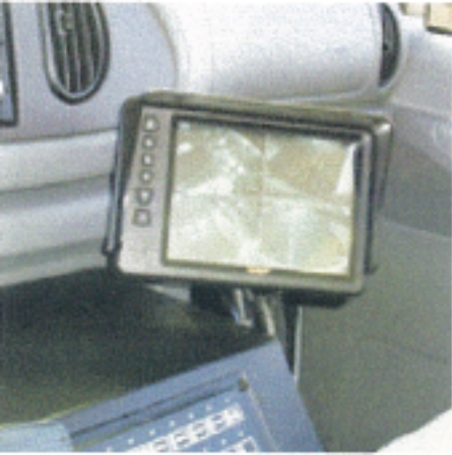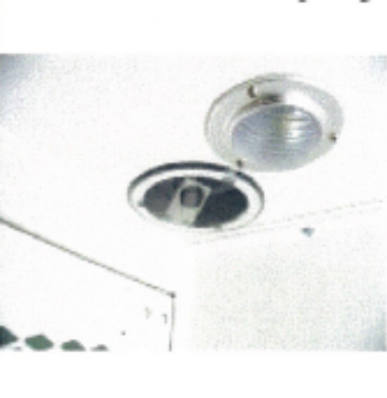

PRISONER TRANSPORT VAN WITH THREE-COMPARTMENT (120") LAYOUT:

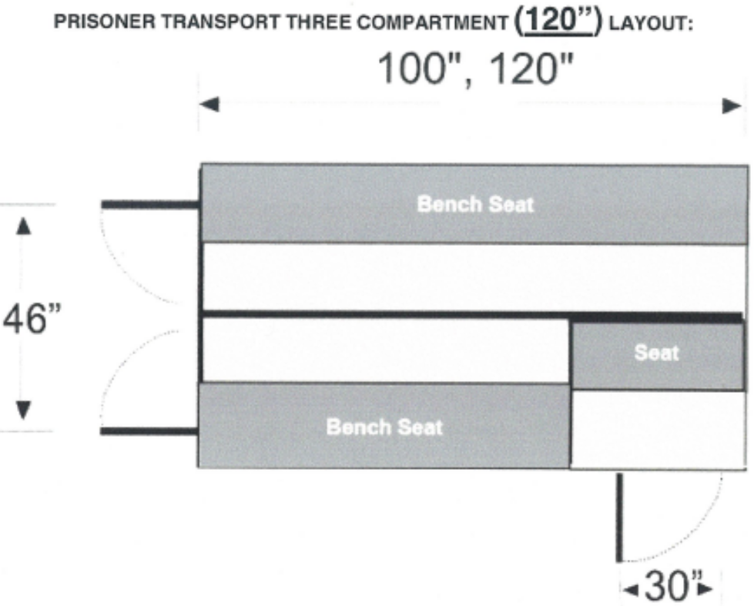

GENERAL DESCRIPTION: It is the intention of this specification to describe a conversion kit capable of installation into a full-size extended cargo van for use as a Law Enforcement Prisoner Transport vehicle. The insert shall provide seating for no less than twelve (12) persons and shall have three (3) separate compartments, one compartment on the left side and two compartments on the right cargo side. See above illustration. The compartment shall allow the loading of prisoners into the rear of the van. The kit will be supplied with all Aluminum primary parts and will be capable of transfer into a new vehicle at a future date. Driver side of rear bulkhead, wall and bench assemblies shall have accommodations for OEM rear air conditioning heat system.

Front Bulkhead: The driver compartment will be protected by a 63" wide X 50" high front bulkhead. It will be constructed from 0.125" thick aluminum sheet metal. The sheet will be formed to provide a framework and will have additional channel welded in for strength. The frame will have pre-punched holes to align with the wall and bench units.
The entire assembly will be attached to bench/walls using 1/4" hardware. The upper section of bulkhead will include a 0.187 thick aluminum X 36"w X 30"h emergency exit hatch, no exception, with two (2) heavy duty slide bolts.
Rear Bulkhead: (DOUBLE REAR DOORS) The rear OEM doors will be protected by a 63" wide X 50" high bulkhead. It shall be constructed from 0.125" thick aluminum sheet metal. The sheet will be formed to provide a framework and will have additional channel welded in for strength. The frame will have pre-punched holes to align with the wall and bench units. The entire assembly will be attached to the bench/walls using 1/4" hardware. This bulkhead will have two (2) rear inner security doors measuring 23" wide X 46" high. The doors will be manufactured from 0.125" thick aluminum sheet metal. The sheet will be formed to provide a 2.125" thick framework and will have additional channel welded in for strength. An exterior door skin will be attached using .187" diameter aluminum rivets. The upper section of door must have a perforated area, which will allow officers to view into the prisoner compartment. Each door includes two (2) heavy duty rotary slam latches. The latches will be activated by a single, flush mounted, paddle handle that includes a key lock and two (2) keys. A secondary, tamperproof access will be provided to override each latch assembly if necessary. The doors will attach to the bulkhead frame using 1/4" hardware and a stainless-steel continuous hinge.

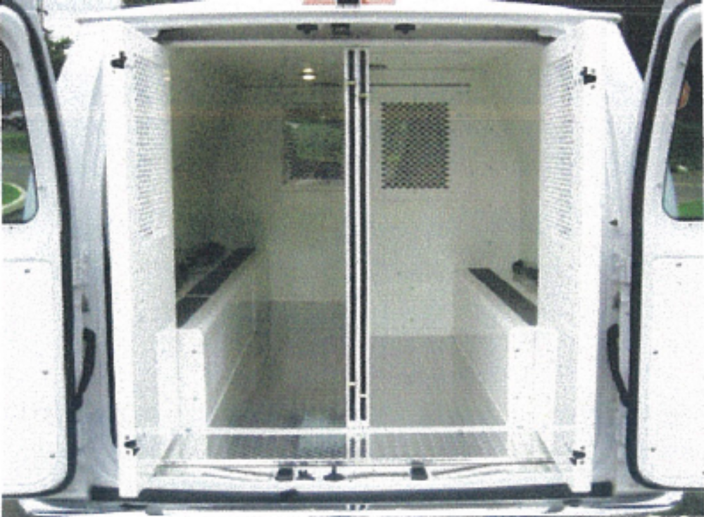
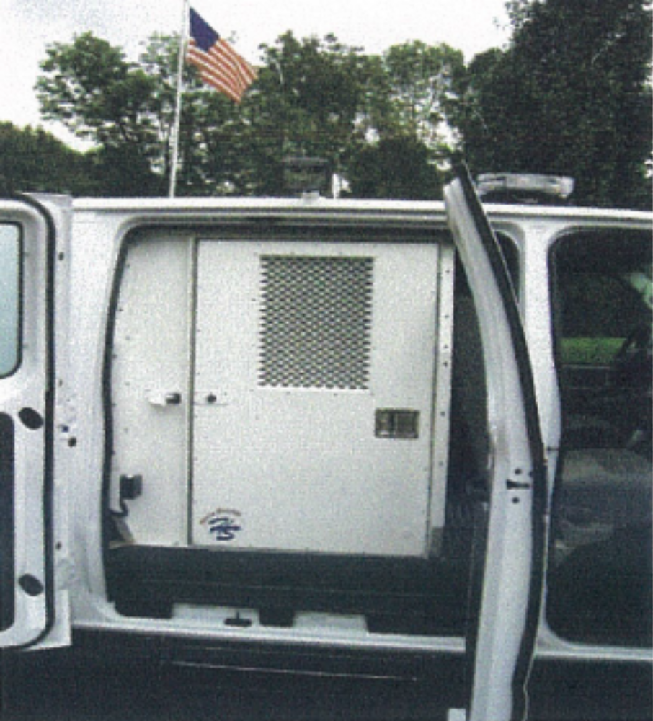

Center Divider: A 117" long center divider with no perforations will separate the rear of van into two (2) halves. It will be constructed from .187" thick aluminum plate. It must be securely anchored to floor, ceiling, and bulkheads.
Benches: Benches will be constructed from .125" thick aluminum with rounded front edges and will include a four-inch (4") wide X full length, rubber "Nonslip" strip on bench tops. The driver side and passenger side benches will both seat six (6) people and will be 13" high X 13" deep X 117" long.
Walls: The driver sidewall will be 38" high X 120" long. The passenger sidewall will also be 38" high by 120" long. Each is constructed from .125" thick aluminum and will be contoured to closely fit the van's interior and the mating bench, ceiling, and bulkheads units.

Ceiling: The ceiling for the rear compartments will be 48" wide X 120" long. The complete ceiling assembly will be a four-piece design with flush, overlapping, bolt together seams for added strength. It will be constructed from .125" thick aluminum and will have pre-cut holes for dome lights and air conditioning / heat vents. The ceiling assembly will bolt to mating walls and bulkheads.
Flooring: The flooring for the rear compartments will be constructed from .125" thick, bright-dipped aluminum tread plate. The main floor is 36" wide X 117" long. Additional 7 1/2" X 48" tread plate will be provided for space between rear bulkhead and OEM rear doors. 1/2" treated plywood shall be installed under this flooring.
Rear Step: A rear step shall be a fold down style to allow prisoners safe ground clearance to exit transport van. The step shall bolt directly to the vehicle frame. It shall be 48" wide by 10" deep. The step shall be constructed from welded steel angle framework and will have a perforated non-slip deck surface. Steel parts shall have a black polyester powder coat finish.
Contractor shall install a light/buzzer warning to notify driver that step is in the deployment mode if the step is a fold down type and/or slide out design. The Contactor shall install a reverse warning device and a rear distance proximity switch to warn driver of rear obstacles and distance. The warning buzzer and indicator shall be in the cab area.

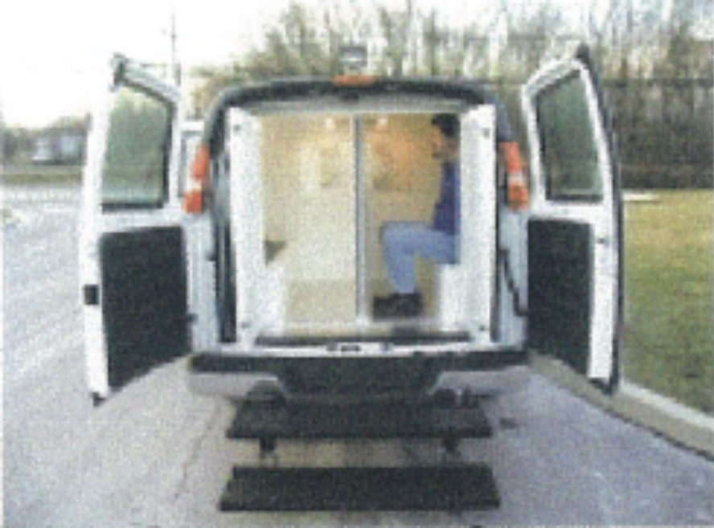

Dome Lights: The driver side rear compartment shall have three (3) 4" diameter stainless steel dome lights. The passenger side rear compartments shall three (3) 4" diameter stainless steel dome lights. All dome lights shall tamperproof .250" thick, clear polycarbonate guards. On/off rocker switch will be in driver compartment dash area.
Seat Belts: KK-BLT "Kwik Kit" seat belt (lap belt) option to be installed for each prisoner location. Seat belts are to be made by a certified automotive belt manufacturer. Seat belts (lap belt) will be mounted to the lower section of the wall. There will be one (1) seat belt per seat location. Seat belts will be positioned so that each prisoner (in waist and leg restraints) can be safely secured to the bench accordance to manufacture's specifications. Each 60" long lap belt will be securely anchored with 1/2" by 1 1/4" button head bolts. If seat belts are chosen, grab straps will NOT be included. The bolts will attach to the bench and wall assemblies. Seat belt instruction manual(s), safety or warning label(s) are to be provided by the manufacturer. Each label includes lettering in English, two (2) for the larger compartment, and one (1) for each of the two (2) smaller compartments. To include any picture labels with two hands holding the seat belt, buckle and/or unbuckle. Two (2) more labels will be provided that read "Drive with Extra Caution While Transporting Passengers". These labels are also yellow with black lettering for mounting on dash of vehicle.
Seat belt illustration:
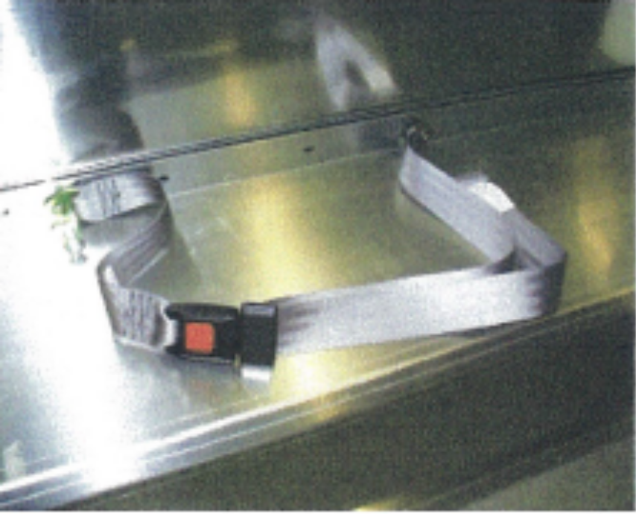
Miscellaneous: When all components of insert are completed assembled and installed, all seams will be sealed with RTV silicone, no exception.
An aluminum plate with white powder coat finish will cover the accommodations in the driver side bench, wall, and rear bulkhead. This cover will guard the OEM air conditioner / heat evaporator blower system from detainees and will allow for easy access when removed for service.
Finish: All aluminum parts will have a super durable White polyester powder coat finish. The profile of the aluminum sub-straight will have proper pretreatment preparation to withstand a minimum of 1,000 hours salt spray exposure (per ASTM-B117 testing). Written test results must be available upon request. All seams shall be silicon sealed and watertight prior to acceptance by the appropriate Authorized Representative for the vehicle or their designee(s). Contractor shall inspect final product and ensure that no sharp edges and/or burs exist in prisoner's compartment.

- Corrosion Standard factory interior / exterior anti-corrosion protection.
Warranty: A Factory Corrosion (rust-through) Coverage Warranty Package shall be provided at no extra charge.

- Contact Persons: All packaged equipment installed by local vendors shall be inspected by the contractor and the installation periodically monitored by the appropriate Authorized Representative for the vehicle or their designee(s).

- Pre-Build Prior to notice to proceed, the Contractor and all equipment
Meeting: installers shall meet with the appropriate Authorized Representative for the vehicle or their designee(s) for a pre-build conference.

- Pre-Delivery Upon completion of the vehicle with the installed specified
Meeting: equipment, the Contractor shall arrange a pre-delivery inspection meeting. The appropriate Authorized Representative for the vehicle or their designee(s) shall review the prisoner transport vehicle. Any corrections or changes as required shall be finalized, prior to vehicle acceptance, and production of the balance of vehicles.
If build is performed outside of Oahu, contractor shall be responsible for all expenses to send the appropriate Authorized Representative for the vehicle or their designee(s) to the build site and absorb all expenses include airfare, lodging, meals, and per diem, etc.

- Vehicle Warranty: The standard warranty protection plan shall be offered. All warranties expressed or implied must be submitted in writing and shall become a part of the bid offering. Maintenance services, adjustments, and any other standard exclusions from the manufacturer's maximum warranty protection plan, shall not be covered.

Use of other than Original Equipment Parts, modifications, and installation of special equipment, such as prisoner compartment kit shall not void the warranty. All warranties, expressed or implied, must be submitted in writing and shall become a part of the vehicle manufacturer's formal bid offering.

- Graphics:

Contractor shall coordinate with ASO or designated facility to obtain and install State of Hawaii supplied vehicle graphics to exterior of vehicle. Note: Verify vehicle ordered has not had a major body model change, which may impede the graphics installation of State of Hawaii supplied graphics set.

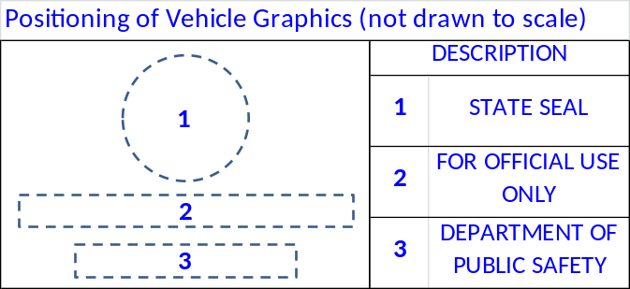

* NOTE: Vehicle furnished under these specifications shall be delivered and invoiced no later than three-hundred and sixty-five days (365) from the date of award:

Delivery Addresses / Authorized Facility Representative
(Locally available unit preferred)
Bid Item: (One) Transport Van with 3-Compartment Insert
Halawa Correctional Facility
99-902 Moanalua Road
Aiea, HI 96701

Point of Contact:
Theodora L. Leatumauga, Business Manager V
(808) 485-3552

